

**Project Proposal**

Course Title: Electrical Devices and Circuits Lab.

Course Code: CSE 216

Project Report Name: Amplifier Circuit

**Submitted To:**

Sakib Mahmood Chowdhury

Lecturer, Department of CSE

Daffodil International University

**Submitted By:**

|  |  |
| --- | --- |
| **Name** | **ID** |
| Md. Zubayrul Hasan | 212-15-14745 |
| Hridoy Kumar | 232-15-013 |
| Fardin Tahsin Rahman | 232-15-065 |
| Md. Arafat Hossain | 232-15-071 |
| Zerin Aktar | 232-15-134 |

**Section: 65-B**

**Group: 06**

**Date of Submission:** 29-10-2024

**Table of Contents**

1. Abstract
2. Introduction
3. Purpose
4. Objective
5. Components
6. Requirements analysis
7. Related works
8. Proposed Circuit Diagram
9. Working Mechanism of Circuit
10. Characteristics
11. Project features and outcomes
12. Project Methodology
13. User interface
14. Design consideration
15. Safety practice and precautions
16. Future scope and limitations
17. Project Costing
18. Conclusion.
19. **Abstract :**

The aim of this project was to design and implement a simple amplifier circuit using basic electronic components. The circuit was constructed on a breadboard and tested for functionality. The report outlines the design process, circuit implementation, testing procedures, and results obtained.

1. **Introduction :**

The purpose of this lab project is to design, construct, and analyze an amplifier circuit that effectively increases the strength of weak electrical signals. Amplifiers play a crucial role in various electronic applications, including audio systems, communication devices, and instrumentation. This project will provide hands-on experience with essential electronic components and deepen our understanding of how amplifiers work.

### ****Purpose :****

The purpose of this project is to provide hands-on experience with analog circuit design and amplification techniques by creating a simple, functional audio amplifier.

1. **Objective :**

The main objective of this project is to:

* Design, build, and test an audio amplifier capable of amplifying low-level audio signals.
* Understand the fundamentals of transistor-based amplification.

1. **Requirements Analysis :**

* Power Supply: A low DC voltage, typically 9V or 12V.
* Transistor: An NPN transistor, such as BC547 or 2N2222, for amplification.
* Components: Resistors, capacitors, and coupling/bypass capacitors for biasing and stability.
* Load: Small speaker or headphone for output testing.

### ****Related Works :****

Various studies and designs demonstrate the role of transistors in amplifying audio signals. The common-emitter amplifier configuration has been widely studied for its simplicity and effectiveness in signal amplification, showing low distortion with sufficient gain.

**7. Components :**

The following components are required to build the Amplifier Circuit:

1. Breadboard,
2. n-p-n Transistors ( BC547),
3. Resistors (2 kΩ),
4. Capacitors (47µF),
5. Speaker,
6. Input Signal Source,
7. Power supply DC(9V).

**8.Proposed Circuit Diagram :**

The circuit diagram for the Amplifier Circuit is shown below--

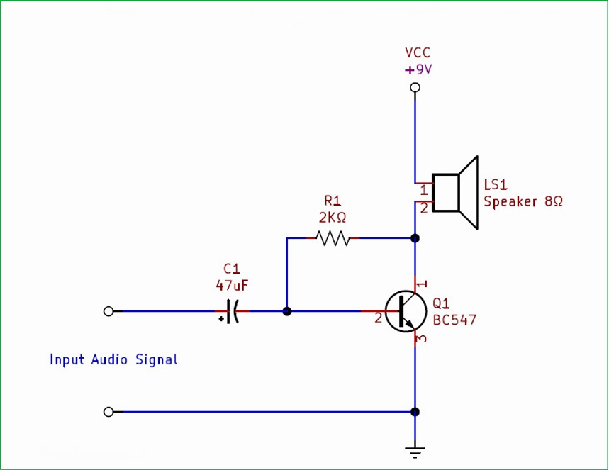

1. ***Working Mechanism of Circuit :***

The n-p-n Transistors (BC547) were placed on the breadboard. The resistors and capacitors were connected to their respective pins according to the circuit design. The Speaker was connected to the output pin of the BC547(collector) and DC power supply(+9V). The Input audio Signal(positive) connected to capacitor(47µF) and Resistor(2kΩ) one side connect capacitor those point connected BC547(base), Resistor other side connected BC547(collector).Ground connected of the Input audio Signal(negative) and BC547(emitter).

1. **Characteristics :**

* **Frequency Response**: Optimized for human hearing range (20 Hz to 20 kHz).
* **Gain**: Moderate gain suitable for small speaker or headphone.
* **Input Impedance**: Typically around 10 kΩ to prevent loading the source.
* **Power Output**: Sufficient to drive a small speaker at a low voltage.

1. **Project Features and Outcomes :**

* A working single-stage amplifier with clear sound reproduction.
* Capability to amplify a variety of audio signals.
* Improved understanding of transistor biasing, AC coupling, and amplifier design.

1. **Project Methodology :**

**Step 1: Component Selection**: Appropriate resistors, capacitors, speaker,

( BC547 ) are chosen based on the requirements of the project.

**Step 2: Circuit Design:** The circuit layout and connections are designed based on the selected components, ensuring proper voltage regulation and current limiting for the Switch using capacitors and resistors.

**Step 3: Circuit Assembly:** The components are assembled onto a breadboard or prototyping board according to the circuit design, ensuring proper connections.

**Step 4: Testing and Debugging**: The assembled circuit is tested to ensure proper functionality, and any issues that may arise are troubleshooted.

**Step 5: User Interface Design**: A user interface is designed for controlling and monitoring , providing an intuitive and user-friendly experience.

1. **User Interface :**

The user interface will be minimal, including:

* **Input Jack:** For audio signal input from a source like an MP3 player.
* **Output Jack:** To connect a speaker.
* **Power Switch:** For turning the circuit on/off.

1. **Design Consideration :**

* **Stability:** Proper biasing for the transistor to prevent thermal runaway.
* **Coupling/Biasing Capacitors:** Chosen to maximize frequency response and minimize distortion.
* **Power Supply:** Chosen for compatibility with the components and desired output volume.

1. **Safety Practices and Precautions :**

* Handle all electrical components carefully, especially the power supply.
* Use proper soldering techniques to prevent short circuits.
* Avoid high volume levels to prevent speaker damage or hearing issues.

1. **Future Scope and Limitations :**

* **Future Scope:** This project can be expanded to a multi-stage amplifier for higher gain, or incorporate a tone control circuit for adjusting audio quality.
* **Limitations:** Limited power output and frequency response; suitable only for small speakers or headphones.

1. **Project Costing :**
2. Resistors: 10 tk (1 pieces )
3. Capacitors: 10 tk
4. Speaker: 60 tk
5. Breadboard: 50 tk
6. Transistors : 40 tk
7. Optional Components: 20 tk (jumper wire ,extra components)
8. Battery: 80 tk

**Total costing:** 270 tk approximately.

1. **Conclusion :**

This project aims to provide a foundational understanding of audio amplification through hands-on experience with a simple transistor amplifier circuit. Successful completion will reinforce knowledge in analog electronics, circuit design, and practical troubleshooting, with applications in audio technology and electronics.